Names __________________________________________________________________________
EDUC 2551 - Elementary School Math: Geometry Project 2

Consider the following object, rectangle ABCD, for problems 1 and 2.
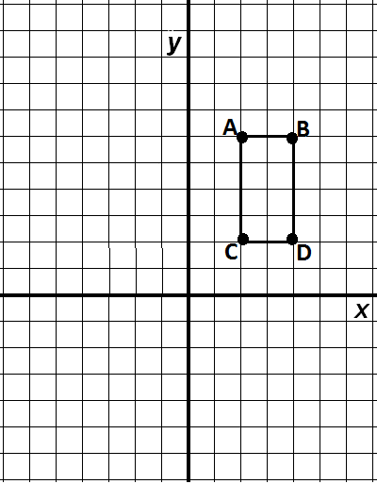
1. Complete the following
a. Find the image of rectangle ABCD after a reflection across the y-axis, label it A’B’C’D’.

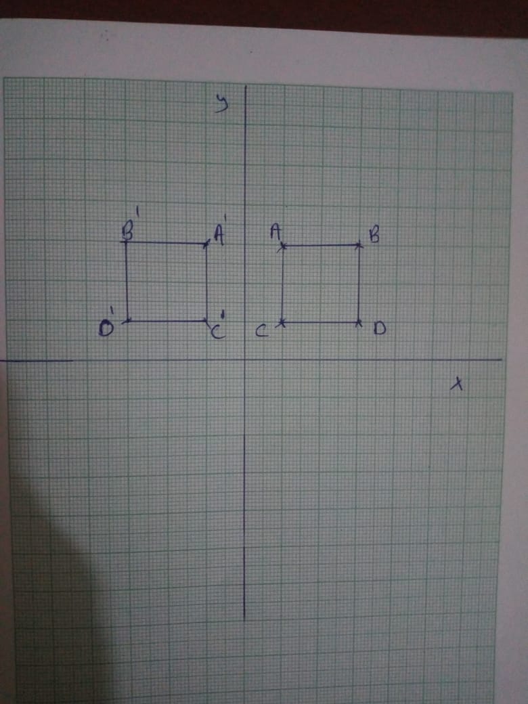

b. Find the image of rectangle A’B’C’D’ after a reflection across the x-axis, Label it A”B”C”D”.
c. Suppose the original points went through a mapping change (x, y) to (x + 5, -y).
Find the new points and label them E, F, G, and H.
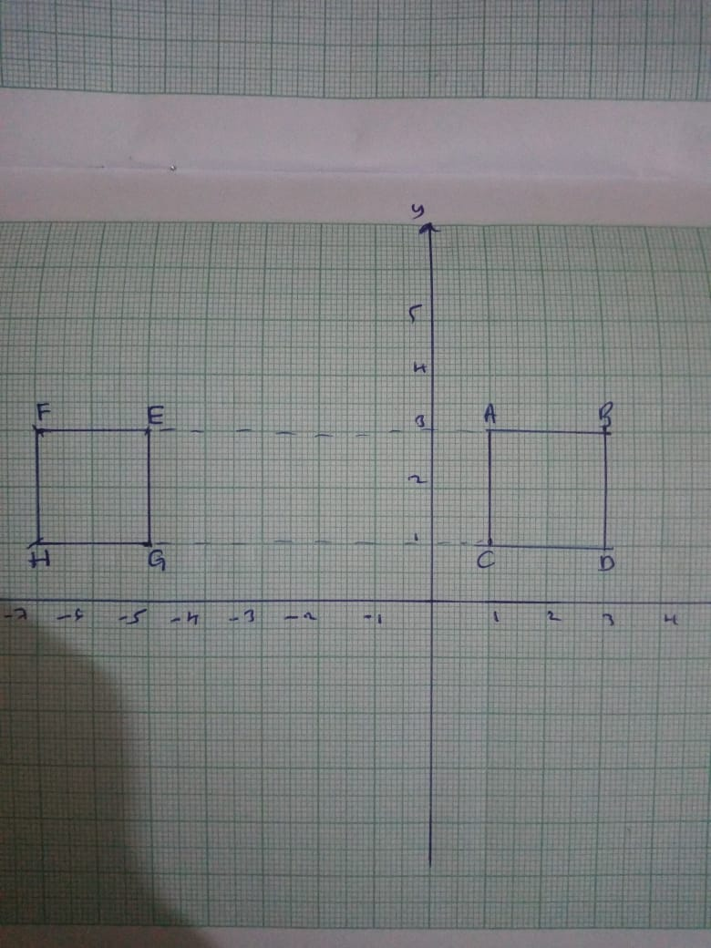
d. What two transformations are depicted in this mapping of rectangle ABCD onto rectangle EFGH?
The coordinates moves away from y axis by 5 units and move in opposite direction of ABCD

2. This time you are going to consider dilations.
a. Dilate rectangle ABCD emanating from the point C and having a scale factor of 2.
What are the vertices (give ordered pairs) for the new image?
A(1,5), B(5,5), C(1,1), D(5, 1)
b. Draw the new rectangle.
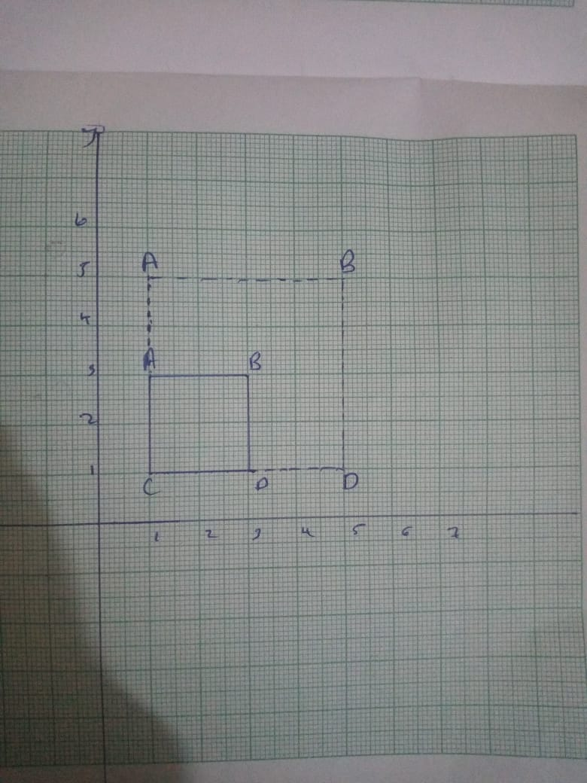
c. Find the ratio of the perimeter of the new rectangle to the old
= 16/8= 2
d. Find the ratio of the area of the new rectangle to the old
=Area of big rectangle= 4*4= 16
=Area of small rectangle= 2*2=4
Ration= 16/4= 4

3. Create a tessellation pattern by starting with an equilateral triangle. Then take out a piece from one side and rotate it and add it to another side of the triangle. With your newly created tile, use it to tessellate a plane. Show your tessellation pattern and the steps needed to make the pattern.
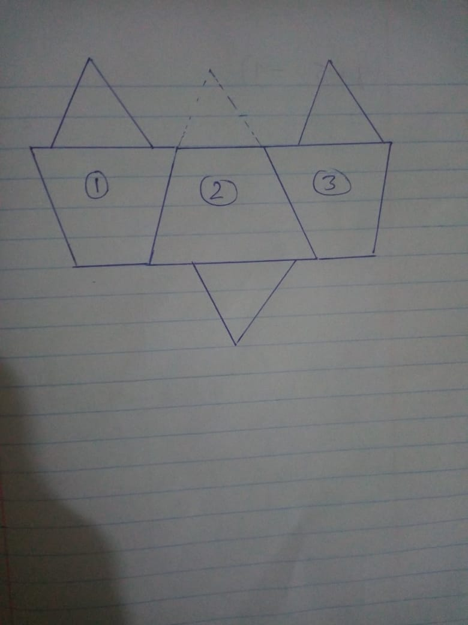

Steps
- Cut the tip of triangle and place it at the base of formed trapezium
- Place other trapezium in a way that they fit each other and place the cut triangle on longer side of trapezium.
4. Suppose line AB is parallel to line DE. Find all the missing angle measures. (Note: figure is not drawn to scale.)

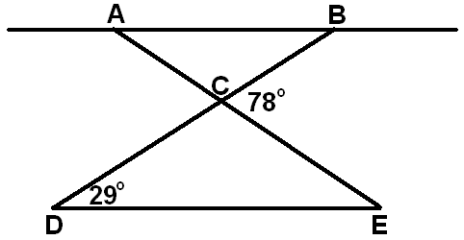
C=180-78= 102
B=29
A=49
E=49

5. Construct a copy of the following using a compass. Show all marks for the construction.
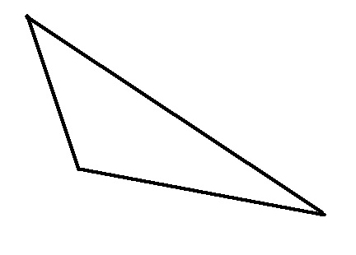
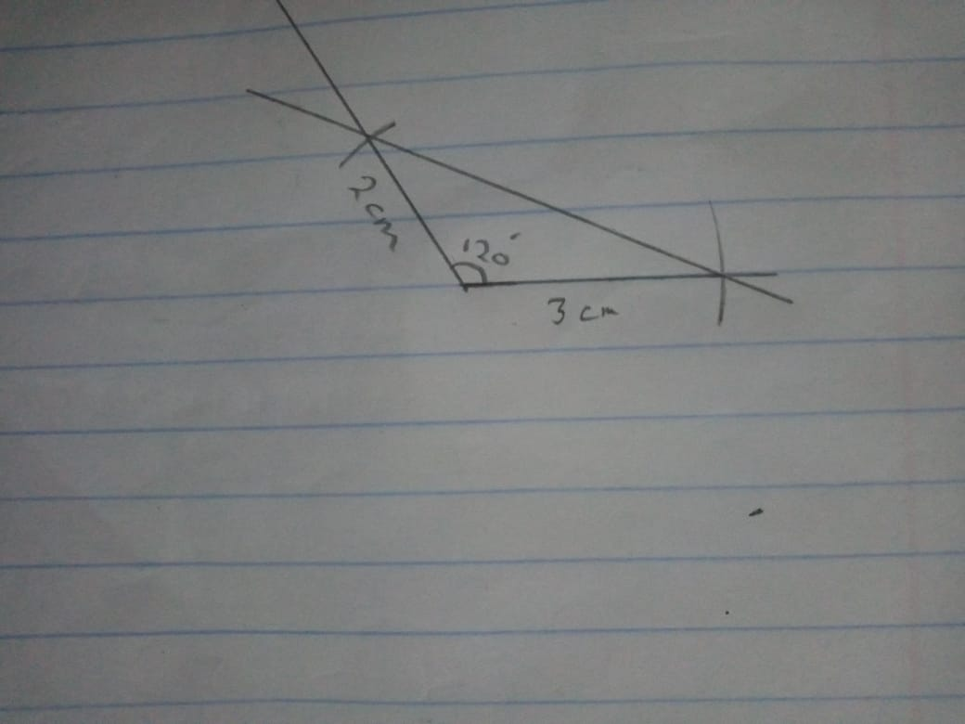

6. Construct the angle bisector for the following angle. Show all marks for the construction.

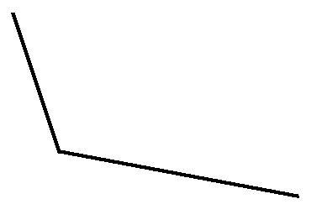
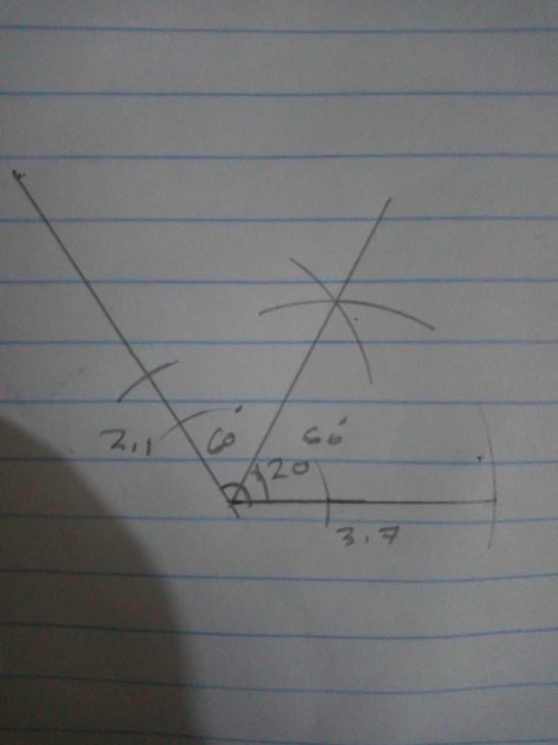
7. Construct the perpendicular bisector of the line segment below. Show all marks for the construction.

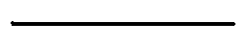

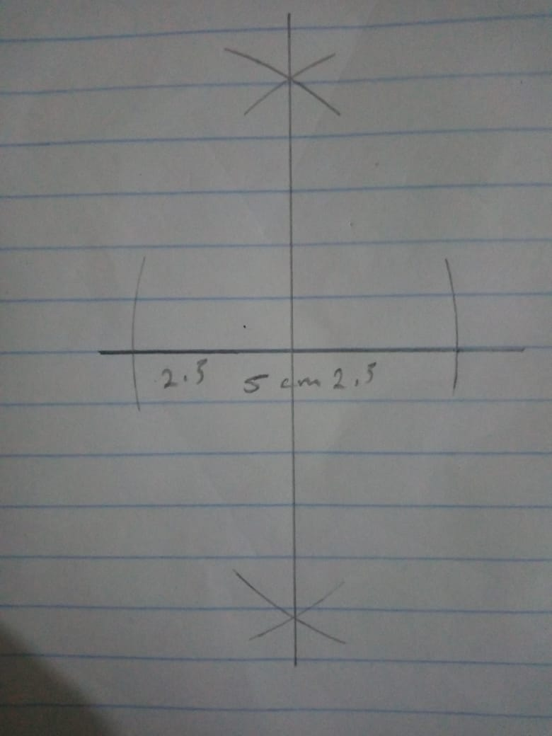

8. Consider the capital letters in the English alphabet. Discuss symmetry for these letters.

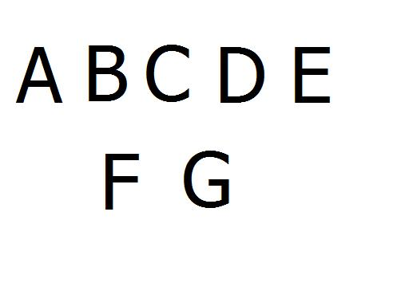

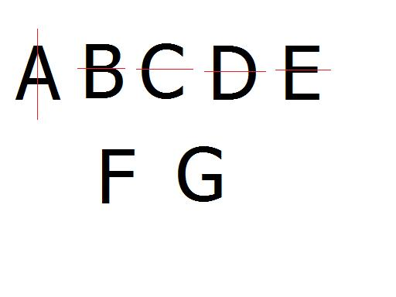
The F and G have zero lines of symmetry. Those letters cannot be folded in half in any way with the parts matching up. The rest of the letters, A, B, C, D, and E all have only 1 line of symmetry. Notice that the A has a vertical line of symmetry, while the B, C, D, and E have a horizontal line of symmetry. Let's look at some more letters!

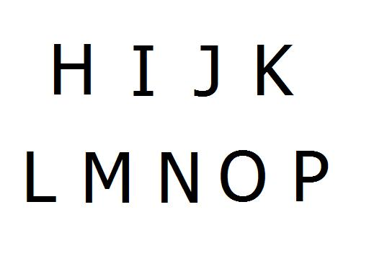
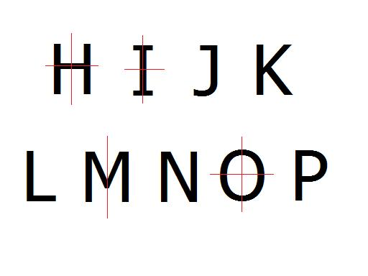

J, K, L, N, and P have zero lines of symmetry. M has one line of symmetry, and H, I, and O have 2 lines of symmetry

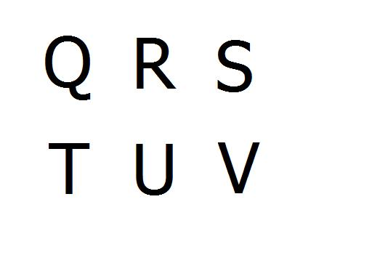
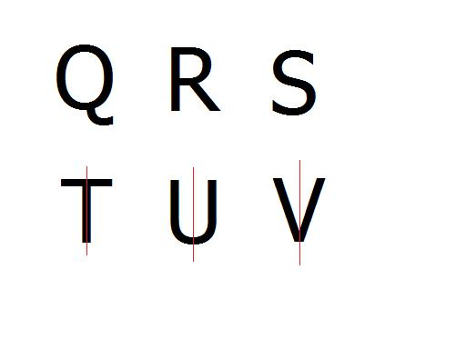
The Q, R, S are not symmetrical, so they have zero lines of symmetry. The T, U, and V are symmetrical, but they each have only one line of symmetry. None of these letters has two lines of symmetry.

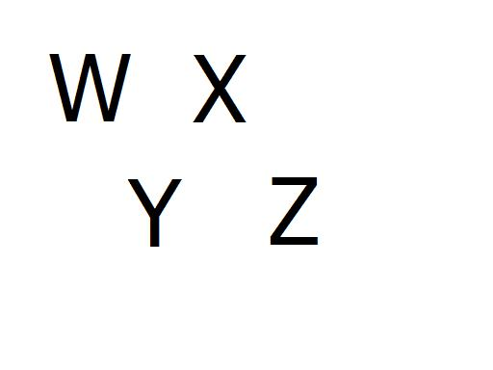
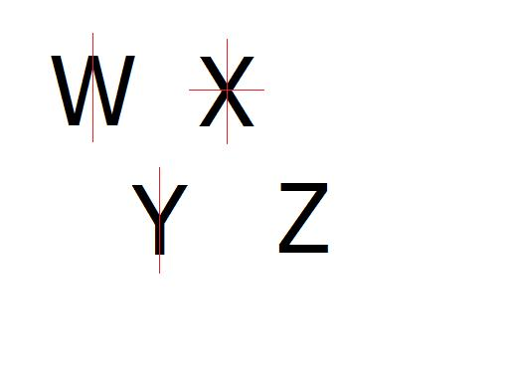
The Z is has no lines of symmetry. The W and Y have one line of symmetry. The X has two lines of symmetry.

9. Find x for the following. Show your work.

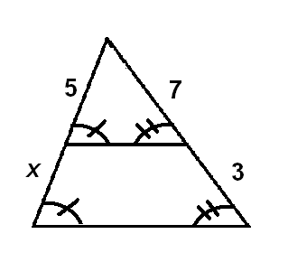
X= (7+3)-5= 5

10. Extra Credit - Starting with a sheet of cardboard that has a right angle corner, construct the following in the least number of steps, using only a straightedge and a compass. Make sure to describe all your steps.
a. a square
b. an equilateral triangle
